Semester II --- Finals study guide

Reading:
There will be three reading passages on your exam: literary nonfiction, expository, and poetry. Be sure to understand the differences in each of these genres:
1. Expository Texts-

2. List the 5 Expository text structures below, including their definitions:
-

-

-

-

-

2. Poetry-
-What is a stanza?

-What is the speaker?

-Define the following:
T-
P-
C-
A-
S-
T-
T-
Review your notes about our different genres and literary devices. Literary devices that you should review in addition to those on your note sheet are:
4. Allusion-

5. Characterization-

6. Imagery-

7. Irony-

8. Author’s Purpose-

9. Personification-

10. Metaphor-

11. Sensory Language-

Writing/ Vocabulary/ Research:

What do the following items stand for?
12. L-
13. M-
14. N-
15. O-
16. P-

17. What is a thesis statement?

18. What parts should a strong thesis statement include?

19. What is the outline of an Expository Essay?

I.
1.
2.
a.
b.
II.
1.
2.
3.
III.
1.
2.
3.
IV.
1.

20. What do the following stand for/what makes a good ACES paragraph?
A-
C-
E-
S-
21. What factors should be considered when writing a research question?

22. How can you verify if a website (.com) is reliable?
-

-

-

-

23. Students are reading the article below, found at nasa.gov. Write an accurate in-text MLA citation for this article:
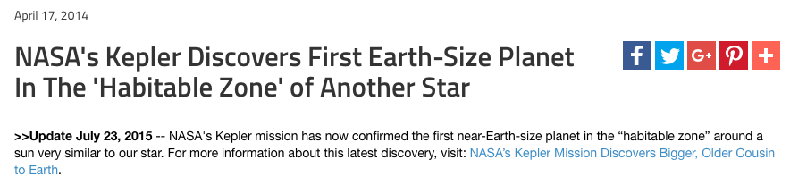

24. Achievement Gap-

25. Opportunity Gap-

26. Blog Post-

27. A header contains:

28. A blog page is:

